Friends of VSSM & Dharampur
C/o. Rashmin C. Sanghvi
220, 2nd floor, Arun Chambers, Tardeo Road, Mumbai - 400 034, India.
Tel. :(+91 22) 2351 1878, 2352 5694  Fax: 2351 5275
Website: www.rashminsanghvi.com  E-mail: rashmin@rashminsanghvi.com

Date: 31st March, 2017
To,
Friends of Dharampur,

Dear friends,

Dharampur Trip. March 2017.

We had gone to Dharampur for three days – 24th, 25th & 26th March. We have visited several different institutions. Please see brief reports together with photographs in the following pages.

 |  | Page No.
1. | Vedchhi Pradesh Seva Samiti. | 2
2. | Swaraj Ashram, Vedchhi. | 3 – 4
3. | ARCH. | 4 – 6
4. | Vanpath Trust. | 6 – 9
5. | Avalkhandi Kelvani Trust. | 9 – 12
6. | Shree Sainath Charitable Trust. | 13 – 15
7. | Sarvodaya Parivar Trust. | 15
8. | Shabri Ashram. | 16
9. | Senior Citizens’ Home. | 16

From Mumbai, we– Ms. Vaishali Chavan, CA Shri Atul Ambavat & myself went to Dharampur.

My chief feelings:

(i) Gandhiji is still alive in the hearts of the trustees & teachers of these tribal schools.

(ii) Significant effort is going on through several NGOs & individuals to improve the life of people and the environment in Dharampur. They are succeeding.

1. Vedchhi Pradesh Seva Samiti (VPSS):
Education.

VPSS was established by Late Shri Jugatram Dave. He was a Gandhian. In the year 1928, at the instructions of Mahatma Gandhi, he left Gandhi Ashram and went to remote village to serve the poor tribal villagers. He established several institutions in Vedchhi. All these are primarily educational institutions. Out of his several institutes, we visited VPSS & Swaraj Ashram, Vedchhi.

Shri Bhikhubhai Vyas started his social service career with VPSS. Hence this is his mother institution. He is still a trustee of VPSS. However, VPSS is mainly functioning in Vedchhi. Shri Bhikhubhai & Smt. Kokiben Vyas have focused their attention on Dharampur. Hence for Dharampur activities they have established a separate trust – Vanpath Trust.

We visited VPSS schools at Kanjod village. It is a beautiful complex on the banks of a river. Shri Bhikhubhai said with justified pride that this whole land was barren in the 1950s. Shri Bhikhubhai & his colleague planted trees and made it beautiful.

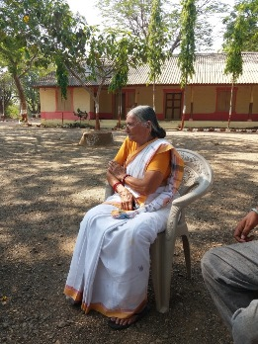

Mrs. Tarlabahen Shah is the president of VPSS. She is managing four schools at different parts of Vedchhi educating totally 700 students.

VPSS gets Government grant for its revenue expense. However, does not get any grant for repairs & renovation of buildings and construction of new buildings. Since most of the buildings are 70 years old and are built with wood and mud. They require replacements. She depends upon donations for replacing old buildings.

Contact Person: Smt. Tarlaben Shah
Mobile No.: 0 97265 64212
Email Address: tandbshah@gmail.com

2. Swaraj Ashram, Vedchhi:
Education. Right atmosphere for study & spirituality.

We visited Swaraj Ashram where Late Shri Jugatram Dave lived. This also is a large complex. When one visualises any Ashram, it would be of this kind. It houses 500 students. The Ashram has maintained a simple room where Jugatkaka lived. And there is a museum containing articles used by him and displaying various photographs of independence struggle.
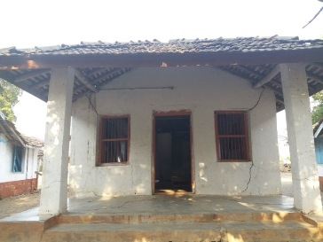

Late Shri Jugatram Dave lived here. This room needs to be renovated properly. Necessary donation has been given by Shri Raoulbhai Sudhirbhai Thackersey.

Shri Jugatkaka was also famous for his spiritual poetry. One poem for which he was loved by people is on the lines: “there is thin invisible curtain between Atma & Parmatma….” A teacher in the school obliged us by singing entire song. I have video recorded entire song. In case, anyone is interested, I can send on Whats App.
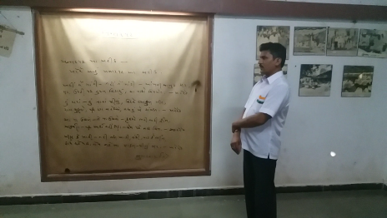

The trustee Shri Madhubhai Chaudhary narrated two instances of his mother – Late Mrs. Genabahen Chaudhary:

(i) In 1930’s Gandhiji came to Vedchhi. As per his usual practice, he would request for donation from all people for the Swaraj Movement. And he would ask all ladies to remove their jewellery & donate. Genabahen was the first lady to remove all her jewellery & donate for the movement.

(ii) We know that consumption of country liquor made from “Mahuda Fruits etc” is very common amongst tribals. Men & women take liquor without any restrain. This is the position today. But while Gandhiji was alive, it was a different matter.

Once Genabahen’s husband was seriously ill. Survival was doubtful. The doctor advised to take a particular medicine with vine. Genabahen said: “I would prefer to be a widow; rather than give vine to my husband”.

Madhubhai, Tarlabahen, Bhikhubhai, Sujata – etc. trustees are still following Gandhiji’s principles in these remote forest villages. God Bless all these Gandhians.

Contact Person: Shri Madhubhai Chaudhari
Mobile No.: 09925328808
Email address: swaraj.va42@gmail.com

3. ARCH:
Medical & Education.

As you are aware, Dr. Daxabahen Patel, the founder promoter of ARCH passed away after a brief illness last year. This time, I had deliberately planned to stay overnight at ARCH, spend more time with the trustees & the Karyakar team; & assure them that our support to ARCH is as solid as ever.

Shri Rashmibhai Kapadia, an educationist is with ARCH for more than 20 years. I stayed at his home and over the discussions at night & at morning tea time, realised that he is a hidden gem. While Daxabahen was present, he did not speak. Now, that he has to share more responsibilities, he spoke in details. He has made in depth study of child education and child psychology. He has read books by the best child psychologists in the world and is practising those principles at ARCH.

Mr. Sudharshan Iyengar has retired from Gujarat Vidyapeeth as its Vice Chancellor. He has joined ARCH as a trustee.

ARCH conducts several activities – medical as well as educational. Medical activities include: Mother & Child Healthcare, Out Patients Department (OPD) in the clinic, a Dental division, a Physiotherapy Division & so on.
ARCH is situated at Nagariya, a small suburb of Dharampur. Seventeen like-minded people came together, purchased a large plot of land adjoining river and built their residences as well as trust premises in this plot. There is abundant greenery. Mornings and evenings are really pleasant with the songs of a variety of birds including – Bulbul, Koyal & Peacock. The whole atmosphere is vibrant and positive.

ARCH has become a magnet attracting several young NRIs from far off countries like Australia, US & France. All these NRIs come here and provide their expertise to ARCH. The trustees have decided to expand Mother & Child Healthcare in more areas and give more intensive benefits to mothers and their infants. Some of the people who have joined ARCH recently.

(i) Ms. Ruchita Choksi – (Physiotherapist, Exercise physiologist):
Came from Australia after eight years’ experience. She is well qualified and experienced physiologist. She has joined the program since January, 2017.

(ii) Her husband Mr. Jigar is closing down establishment at Australia and will join ARCH in a few months.

(iii) Ms. Swati Desai- (B. Sc, B.Ed & PGDCA)
-17 years of experience in teaching in schools of Surat city. Currently she is engaged in documenting women opd and developing modules for training for adolescent based on ARCH experience. She will be prime associate with Laxmi to strengthen adolescent program next year.

(iv) Mr. Nrupesh Patel- (Experience in Accounting and Finance).
Returned to India after eight years in England. An enthusiastic explorer joined ARCH a year back. Interested to learn how children learn and wish to explore the process more deeply. Presently engaged in Balwadi, morning class. Actively involved and co-coordinating mobile Library program in government schools.

(v) Dipti Patel – (Over 8 years of work experience in retail industry in England.)
Actively involved in day to day operation and development of balvadi. Introduced animation based story sessions and additional learning measures to children for hygiene and sanitation. Looking after campus landscape maintenance and development. Experimenting with Amrut Krushi on small scale at present but wish to take it further.

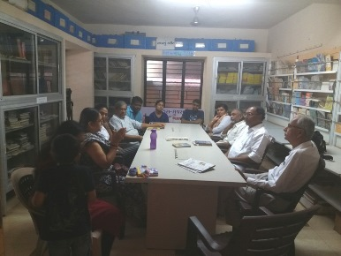

A meeting at ARCH centre. Dr. Laxmi bahen is explaining medical activities of the Trust.

Contact Person: Shri Rashmibhai Kapadia
Mobile No.: 098791 78223
Email Address: rashmidharampur@yahoo.com

4. Vanpath Trust: Shri Bhikhubhai Vyas & Smt. Kokilabahen Vyas.
Education & Water Management.

Vanpath Trust runs totally seven schools and educates about 650 children. These are Ashram Shalas. In all cases, the children stay in the Ashram. In some cases, they study at Vanpath schools. In some cases, they go to nearby government schools for formal education. In all cases, Vanpath Trust provides additional tution by the teachers employed under Vanpath Trust.

This trust has been carrying on water management work on a large scale. In fact, Bhikhubhai & Kokiben have been the pioneers of water management in Dharampur. Santu & Ladak are the prime movers – leaders in water management. By now, Vanpath Trust has built more than 400 checkdams. They have also built bandhpalas / soil bunding covering an area far larger than the coverage by 400 checkdams.

In this visit, Santu & Ladak showed us some significant innovative projects.

4.2 Veri Bhavada village:
In schools, the science students are taught the experiment of “Buck Hose” or “Siphoning Hose”. Water can be transferred from a higher level to a lower level through a hose without the use of any power. It operates on the principle of difference in air – pressures at two different points. Santu has used this principle efficiently.

Santu & Ladak took us to a farm on a mountain. For this visit, we went from Bilpudi by car for a long distance. Then further road was not motorable. They had already planned and called for a jeep. We changed from our cars to the jeep and went further into the mountain. Thereafter there was no further jeepable road. Hence we had to get down from the jeep and climb the mountain further. While all of us climbed, it was heartening to see Bhikhubhai at age 84 years climbing the mountain under harsh sun.

Santu took us to a small pond in his farm. The bottom of this pond of about ten feet diameter and about three feet depth is entirely covered with plastic. How does he get water in this little pond?

Santu & Ladak have built three check dams on top of another mountain. Because of these check dams, there is good percolation of water in the mountain. All the villagers have agreed that after the monsoon, the check dam water will not be used for irrigation. It is meant for human consumption and animal consumption. However, from the middle of the mountain, a stream comes out because of the underground water. In this stream, Santu & Ladak made a small pond somewhere 500 feet above the valley. From the pond in the stream, they have fixed a thousand feet long pipe. The pipe goes all the way down the valley and then again comes up on the opposite mountain where Santu had taken us. Once the pipe is filled in water, purely because of difference in air pressures at the two different points, the water comes up on the second mountain. On this mountain, Santu had made a small pond of ten feet diameter. Again independent pipelines have been laid taking water from this small pond to several surrounding farms. Mango and other plants are watered once every fortnight. All trees and vegetable plants are provided with organic manure made from agricultural waste & cow dung.

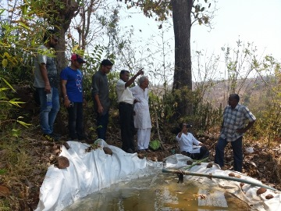

Ladak explaining to us how Buck Hose of 1,000 feet length has been installed to bring water from opposite mountain across the valley.

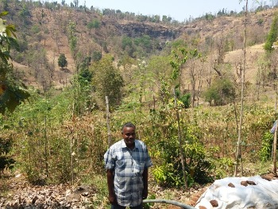
Santu standing in his farm. Behind him is a valley. Across the valley is another mountain. Black portion seen on the mountain becomes waterfall in monsoon.

They get water from this mountain by buck hose.

With this irrigation system and tree plantation, organic manure, etc. as per Santu’s estimate the farmers’ annual incomes have gone up by more than Rs. 20 lakhs. In a poor area like Dharampur, this is significant income. And entire system has been set up with no running cost and extremely low capital cost (just the cost of pipes). Truly it is a tremendously innovative idea.

In fact, while describing this success story, Santu (aged about u50 years) almost cried with joy.

4.3 Village Matuniya: Santu & Ladak took us to another site. Little did he care that 25th March was extremely hot day, we were moving around in the mountains between 11.00 a.m. & 2.00 p.m. and had not taken our lunch. He was so enthusiastic with his project that nothing else mattered.

He took us to a small well. The fact that the well had clean drinking water on 25th March is a success story. In Mumbai, when we can get for 24 hours a day - water by just opening the tap, we do not realise the significance of a successful well.
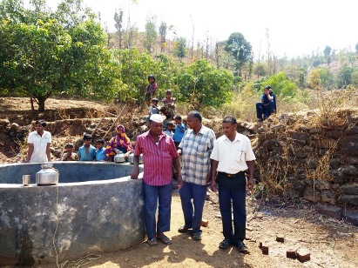

Our True Heroes – Santu & Ladak with villagers.

This well was successful because at a distance of more than one kilometer, the Vanpath team had built a good size checkdam. When the checkdam was built, inside the pond, they dug out and removed soil for some depth. At that stage, underground water came out in the pond and entire pond became muddy. At the site of underground water, the villagers were so happy that they all started dancing and throwing mud at each other. In the melee caused by joyous dancing, one woman broke her leg and had to be hospitalised.

When we realise that in the absence of these check dams and wells, the tribals would be walking long distances with two pots on head and the third pot on the waist – we understand the joy of a successful check dams and a successful well.
It is a solid proof that your donations make a significant difference in the lives of poor tribals in the forest. Thanks to Vanpath Trust, their trustees and entire team. Thanks to all the friends of Dharampur.

4.4 Vanpath Trust

I am sorry to share with you a sad part of the movement.
Shri Bhikhubhai is aged about 84 years & Kokibahen is aged about 78 years. Both of them are weak & cannot cope up with the work. Out of their weakness, they have closed down one school at village Veerakshetra. Even from other schools, students are going away to nearby Ashramshalas run by other institutions. And yet, Kokilabahen is not ready to appoint a successor or to develop second line of management. This trust is on decline as ageing trustee is not ready to delegate her powers to younger people.

We pray God for their long life and excellent health.

Contact Person: Shri Bhikhubhai Vyas
Mobile No.: 09429885232
Email Address: bhikhuvyas@gmail.com

5. Shri Krushnaraj Thackersey Hostel.
Avalkhandi Kelvani Trust (AKT):
Education, Water Management, Micro Finance, Tree Plantation.

Avalkhandi was selected for our work only three years back. It is still poorer compared to other areas where extensive irrigation work has been completed.
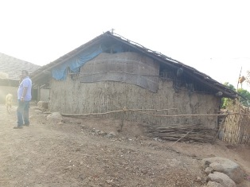
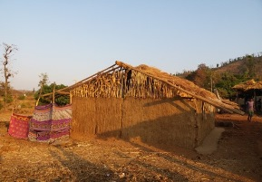

This family is even poorer. Walls are made of sticks that remain after harvesting Jowar.
This house in Avalkhandi is made of Karvi sticks & mud plaster. Other areas in Dharampur now have brick houses.

On 25th afternoon, we reached Avalkhandi and met the trustees
Shri Navinbhai Gavit & Shri Kantibhai Chaudhari. About 160 students (girls & boys stay in Shree Krushnaraj Thackersey Hostel and about 300 students study in the nearby Government school. Other 140 students come directly from their homes to the school.

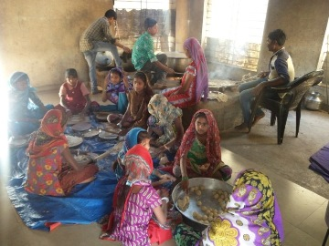
Hostel has cooks who do main cooking work. However, children also help.

Separate groups of students are made –each group having different responsibilities. These responsibilities are rotated every week.

CA Shri Atulbhai Doshi & Ms. Trupti Nisar (Core Group, Friends of Dharampur) look after the educational activities of AKT. Both of them make it a point to help all the 300 students and teachers. The principle is: we want to help all the tribal students. Those who come from long distances require hostel facility. Those who stay near the school do not require hostel facility but can certainly benefit from AKT’s educational activities.
Avalkhandi is a small village with 162 families (approximately 800 individuals). This small village is spread out in five different hamlets. Some hamlets are as small as having 15 families.

In this small village, when 300 students come for studies and 160 students and the relevant staffs stay permanently, there is tremendous pressure on availability of water. So far, there was only one source for water – a bore at the Government school. This bore supplies water to the school, to the hostel and even some of the villagers. The water supply is inadequate. Hence with the help of Swami Vivekanand Charitable Trust lead by Dr. Dolatbhai Desai, AKT has installed a 3 km. long pipe line to bring water from Vangan falia.

Vangan Falia is part of Avalkhandi village but situated in the valley. A small river passes through the valley and demarcates the border between Gujarat & Maharashtra. This stream is barely 10 feet wide. Yet, Government has constructed several check dams on the stream. Because of water percolating from both sides of the mountains as well as water coming through the stream, there is abundant underground water at Vangan Falia. There are four wells in the area – all full of water. From one of the wells, AKT has installed the pipe line to bring water to the hostel. It is a difficult job to carry the water thousand feet up in the mountain. And this project is being maintained and managed by our Kantibhai. (10th standard pass.)

I had anticipated big increase in the demand for water because of: (i) students at the hostel; & (ii) massive increase in agricultural activities that we have planned. Hence we need a massive increase in water supply. For this purpose, the idea is to cover entire mountains in Avalkhandi village by bandhpalas, checkdams & trees. All these help in percolation of water in the underground. The underground water then comes out as small streams or through the wells and bores.
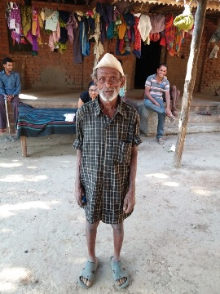

Kantibhai took us to Vangan Faliya to see Bandhpala = Soil bunding work. This gentle man has made a stone wall in his farm. We went to his farm.

When we saw huge boulders at the bottom of his bandhpalas, we just could not believe – how could he have shifted these huge boulders manually?

So he called his family members together with the tools they used.
Two or three families work together by turn in every farm. They push & move stones from higher levels to lower levels & then arrange.
Huge stones will ensure that the retaining wall will not collapse even in very heavy rains.

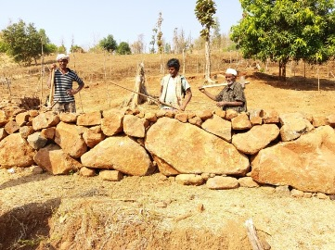

This year, we have allocated bandhpalas work to each and every family in AKT. The idea is that all the mountains between five different Falias of Avalkhandi should be fully covered with bandhpalas.
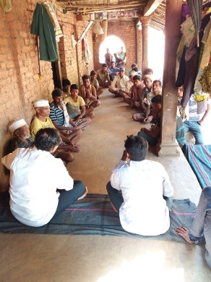

Discussing with the villagers at Vangan Faliya - water management and tree plantation plans for April to June 2017.

This year we will also give three mango saplings to each family. We are prepared to give even more. However, the villagers said that in one year, they cannot grow more than three saplings. Reason is these plants have to be watered for eight months. They do not get sufficient water during summer to grow more than three plants. Our scheme is: AKT will purchase mango saplings from Nursery. Half the cost of saplings will be borne by AKT and the other half should be paid by the villagers. Transport cost will be borne by AKT. Slowly as more and more water is available, more and more trees will be planted and more farmers will take two crops per year (instead of only monsoon crop at present). As a macro plan, we envisage substantial increase in income for every family in Avalkhandi.

Contact Person: CA Mr. Atul Doshi
Mobile No.: 98211 27475
Email Address: atul@ahaholdings.co.in
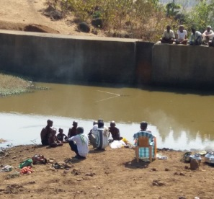
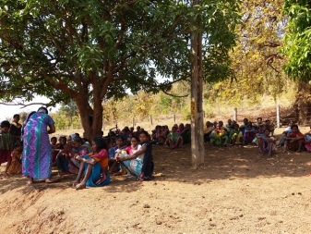

While travelling from Avalkhandi to Dharampur, we met these groups of people. A relative had died. On 26th March, it was 12th day. As per Hindu rites, men have to remove hair & take a bath in lake/ river. In absence of lake; and rivers being dry, they took a dip in the checkdam water.

6. Shree Sainath Charitable Trust:
This is a new trust included in our group of charitable trusts to be supported.

6.1 Kidney Dialysis Unit:

Shri Nitinbhai Shah is a wholesale trader in pharmaceutical products. He lives in Vapi. About 20 years back, he started Kidney Dialysis unit at Dharampur with three machines. Recently, (in the month of March, 2017), he has set up two more dialysis machines. With the five machines, every day he provides dialysis treatment to atleast 15 patients. The regular visitors are: (i) patients suffering from Kidney problems &
(ii) tribals victims of snake bites. There are many instances of snake bites. Many times, the snakes are not poisonous. In such cases, the doctor gives first aid treatment and the patients go home. However, if the snake is poisonous, first major medical treatment is provided at the nearby Sainath Hospital, thereafter, the patient needs extended dialysis treatment at Shree Sainath Charitable Trust.

Nitinbhai provides this medical service completely free of charge.

As per the Government scheme, the local municipality is supposed to reimburse 50% of the material cost. However, Nitinbhai is not a “Smart Man”. Hence the bureaucrats make arbitrary cuts in the grant and cause inordinate delays. At present, Nitinbhai has not received a grant of Rs. 20 lakhs for last 15 months. He collects small donations from his friends and relatives in Vapi & Valsad area; requests his suppliers to wait for payments as long as possible. As on 1st March, 2017, he had not paid salary for last three months and electricity supplier company was threatening disconnection for non-payment of bills.

We have now stepped in and would like to help Nitinbhai.

CA Shri Virendrabhai Shah, a prominent chartered accountant practising at Valsad & Mumbai had also joined in the visit. Both of us had detailed discussions with Shri Nitinbhai. It was apparent that with the tremendous tension, he was broken from inside. Apparently he was smiling. But his heart was crying. He had continuous tension of “How will I face my suppliers?” Because of this tension, he has been diagnosed with diabetes. Our immediate plan is to collect donation of Rs. 25 lakhs and help Shree Sainath Charitable Trust. Out of this target, we have already received cheques for Rs. 15 lakhs. Now we appeal to you for a further donation of Rs. 10 lakhs to Shree Sainath Charitable Trust.

6.2 Vadil Vatsalyadham / Senior citizens’ Home:

Shri Nitinbhai has, during the current year started a new institution called Vatsalyadham. His is a home for poor tribals aged above sixty years – who have no source of income. In Dharampur in some areas even young people earn barely enough to run their homes. They don’t have any savings. When these people become old & unable to work, their position is pathetic. To look after such poor old people, Nitinbhai has started this new institution.

Smt Meenabahen is a tribal lady from Dharampur. Her husband died in illness. She had approximately five acres of land. Out of this, she has donated more than one acre to Shree Sainath Charitable Trust.

Trust has employed people to cook food for the residents & to wash their clothes & utensils. All residents can actually live a life – more comfortable than what they lived in their own homes. And yet it would be the life of a lower middle class family.

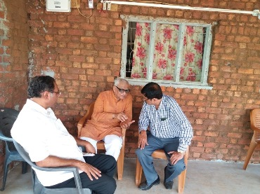
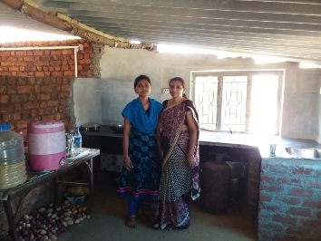
CA Shri Virendrabhai Shah in talks with
Shri Nitin bhai Shah. Virendrabhai is a great blessing to Charitable Trusts working in Dharampur. He & his colleagues from Lions Club of Valsad have agreed to help Nitinbhai in accounts & audit matters.
Meena bahen & her daughter-in-law Priyanka. Meena bahen donated the land for the Vatsalyadham. Her whole family came in to help Nitinbhai in cooking food for us & serving us the food.
I have yet to learn humility from Dharampur tribal donors.

Some seniors staying at Vadil Vatsalyadham at Zero charge.
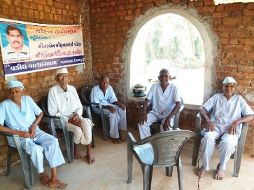

Some seniors staying at Vadil Vatsalyadham at Zero charge.

Shri Nitinbhai has big plans to build large accommodation for many senior citizens. He has enough land. However, funds is the main constrain. Hence he has built a temporary shed for stay, kitchen & toilet facilities. At appropriate time this building can be dismantled & a leger one can be built on the same place. Brick are plastered with only mud. So they can be removed without any damage and reused in new building. For any donor interested in helping Senior Citizens’ Home, this is an excellent institution with committed trustees.

Contact Person: Shri Nitinbhai Shah
Mobile No.: 09913550545
Email Address: shreesainathdialysiscenter@gmail.com
info@shreesainathdialysiscenter.org

Trust Banking Details:
Account Name: Shree Sainath Charitable Trust
Bank Name: Central Bank of India
A/c. No. 3208002570
Branch: Dharampur branch
IFSC Code: CBIN0282299
PAN No.: AALTS 9054 P

7. Sarvodaya Parivar Trust (SPT):
This trust, now under the leadership of Ms. Suajata Shah & team is our old & established friend. I won’t go into details. Brief matters: Sujata does most extensive & systematic work in Dharampur on water management & tree plantation. For the year 2017-18, SPT has taken up ambitious project of water management & tree planation with a budget of Rs. 88 lakh.

SPT has also taken up an ambitious project of replacing old school buildings at Pindaval. Total cost of new buildings will be Rs. 250 lakh.

I sincerely recommend extensive support to SPT.

Contact Person: Ms. Sujatabahen Shah
Mobile No.: 09825873338 / 09429346539
Email Address: pindvalvinoba@gmail.com
8. Shabri Ashram: K. M. Sonawala Charitable Trust.
Education.

Because of scarcity of time, we could not visit Shabri Ashram situated at Kaparada. Trustee Shri Nitinbhai Sonawala has taken up extensive programme for expansion.

This trust runs a hostel exclusively for tribal girl students. They also look after character building and overall support for the students. By now, many girls have completed education and some of them are at important positions in Government.

Contact Person: Trustee Shri Nitinbhai Sonawala
Mobile No.: 98200 61259
Email Address: nsonawala09@gmail.com

9. Vaishali Chavan:
Senior Citizens’ Home.

Here is a young banker, a senior manager in an MNC bank. She has given resignation from the job because her passion is – to provide warmth, love, dignity & security to senior citizens. She has started helping seniors – whose children may have settled abroad or otherwise they have no personal support. They are financially independent & have their own homes. But since they have no children or the children are far & away – they lack warmth in life.

Vaishali has joined our team for about six months. I am showing her all the NGOs whom we support. We will help her fulfil her dream.

Contact Person: Ms. Vaishali Chavan
Mobile No.: 9820467802
Email Address: vaishali.chavan1073@gmail.com

People like Sujata, Mittal Patel, & Vaishali are the hope of India. They prove the fact that - young generation also is keen to help India become a better place to live in, and grow.

On the whole, excellent work is going on in Dharampur – Kaparada. All of you – the Friends of Dharampur are an important source for morale boosting and support.

For friends of Dharampur & VSSM
Convenor

Rashmin Sanghvi

